Cub Scout Leader Training Opportunities

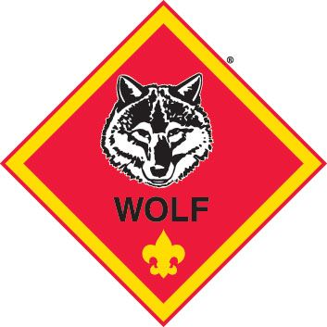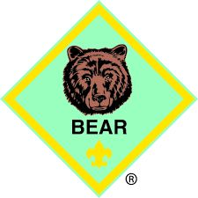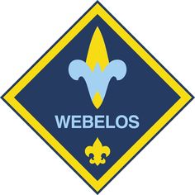
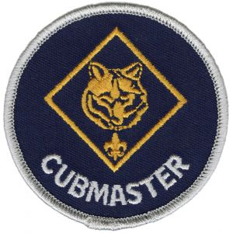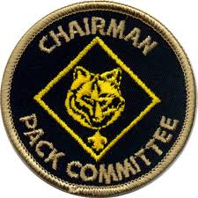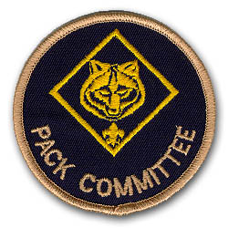
What: Den Leader Specific Training
Cubmaster Specific Training
Pack Committee Specific Training

Date: October 16, 2021

Time: 8:30am Registration
9:00am to noon

Where: Scout service center
Schuette Hall

Note: Den Leader Specific Training covers Tiger, Wolf, Bear and Webelos Leader training at the same time.

Pack Committee Specific Training covers Committee Chair and Committee Members.

Cubmaster Specific Training covers Cubmasters.

